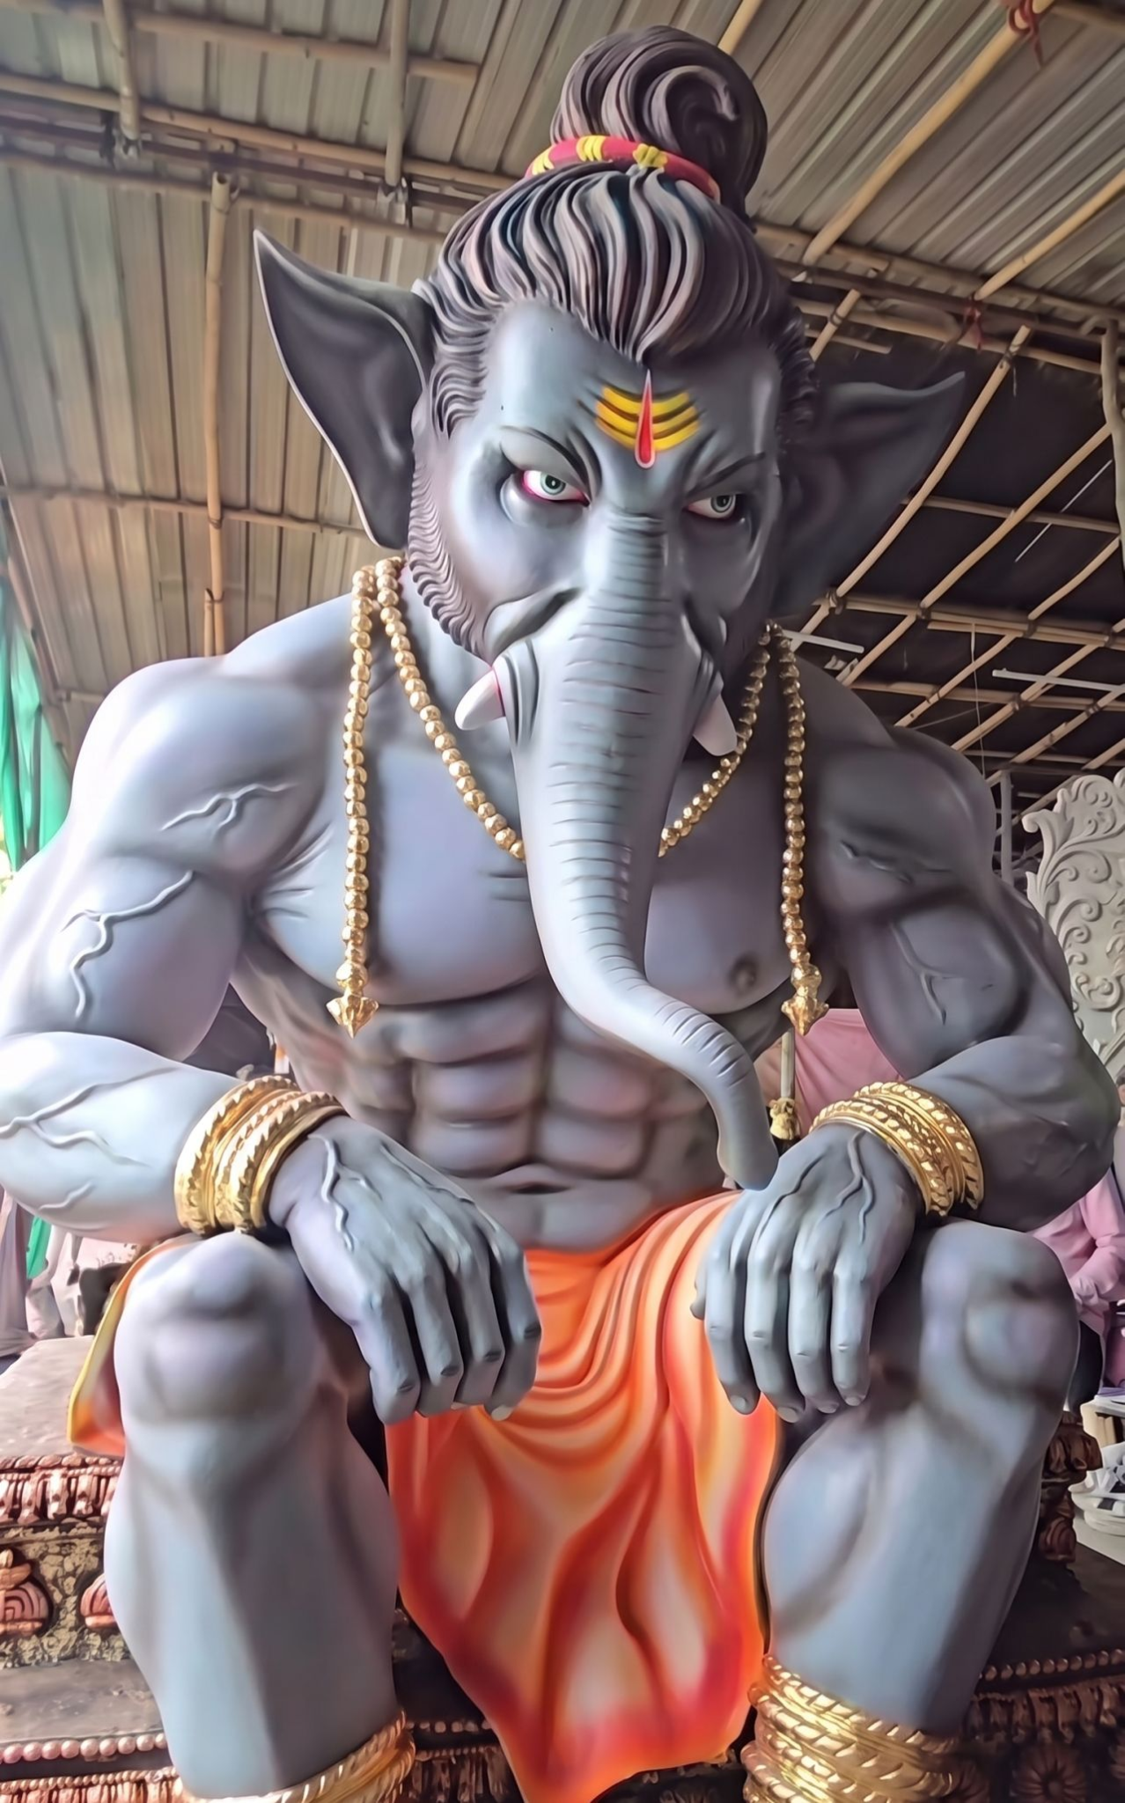
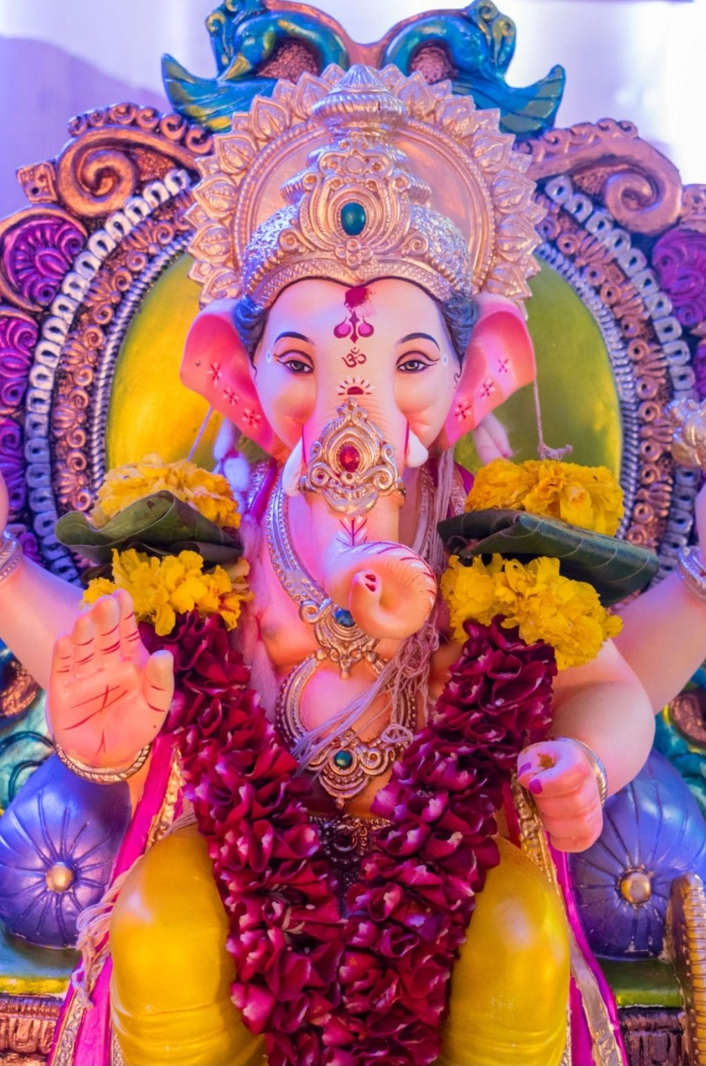
There's a new Ganesha in town.

I was in Mysore yesterday and a particular banner caught my eye.

Faces of young men, between the ages of 16-25, surrounding a Ganesha I hadn't seen before- a Muscular Ganesha, with his six-pack abs and politician-like attire.

Guys, there was at least one god I could relate to: my dear Lambodar, with his lamba udar, devouring modak, comfortable, knowing sometimes, buddhi is enough. He too was sent to the gym.

But that is not the first thing that catches your attention.

The physical manifestation of masculinity has always had forms ranging from Vishnu's supple features representing the fluidity required to keep the world running, through the yugas, to Hanuman's musculature, lifting mountains, and the same Hanuman being in deep meditative states, in non-muscular, ascetic forms.

What stands out is the expression. This new, emerging Ganesha was angry, ready to charge with all his energy onto an unjust world.

Over the past 10 years, Hanuman has undergone a similar shift, going from the benevolent devotee of lord Ram, who used to adorn dashboards facing the family inside, offering peace and protection, to now being angry, looking outward, becoming a warning sign to those both behind and ahead of you.

Clearly, what men are feeling in today's world has shifted.

In a world that saw waves of Andrew Tates & movies such as Kabir Singh and Animal, it is easy to label it as toxic masculinity and move on.

But if you take a pause, relook, and wonder: first, the god representing duty, strength & complete devotion, and then the god that represents intelligence, patience and mastery, are both angrier; you realise there is more to the story.

You realise that in a world where women have entered driving autos to power lifting, from topping exams to being placed better, at least in perception, a young man finds it increasingly more difficult to find his place in the world.

The system too, doesn't promise to have his back. (AI, Gig economy, Agniveer)

And every other thing that they could latch on to- old-money looks of linen pants, or pumping oneself with steroids to gain a form the XX chromosome can not dream to achieve- move towards a desire for distinction, differentiation: and hopefully attention, from the other side, which now can reject you.

A generation of men, challenged at each step, hoping to get a right swipe, from employers, elders, their own groups & potential partners, all at the same time.

The playbook shifts every month, trend cycles move faster than ever, and all you want is to look the world in the eye and ask it to back off for a minute.

Ganesha, in a world without Riddhi (Prosperity) and Siddhi (Mastery), and Hanuman, who longs for a Ram (Faith), grow weary. This is not the same as ugra swaroop of the deities.

Modak doesn't cut it anymore.

What must the new gods be offered?

